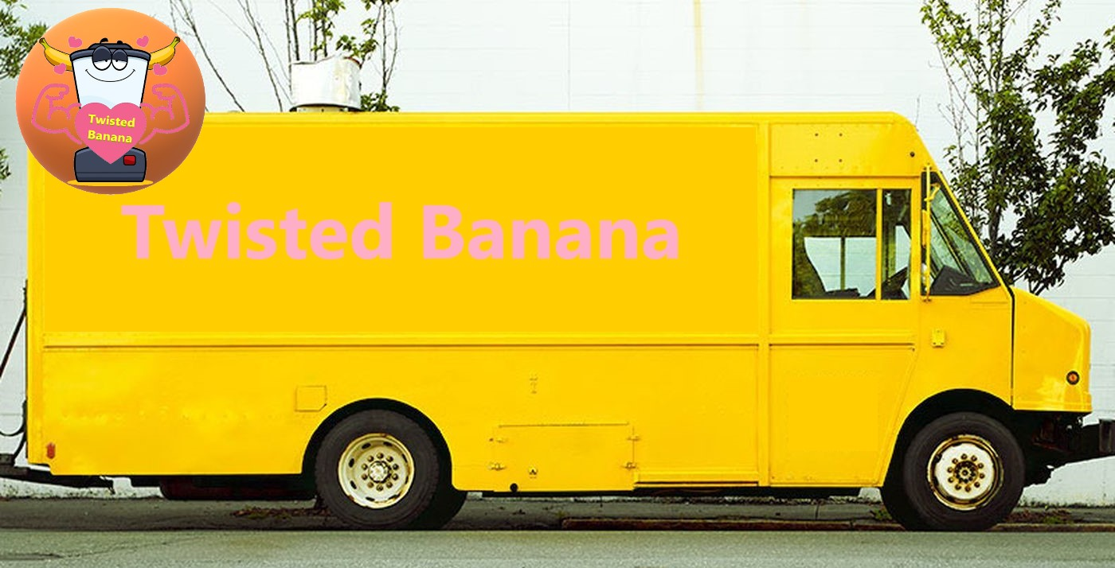

**Twisted Banana. Healthy food options at your front door.**

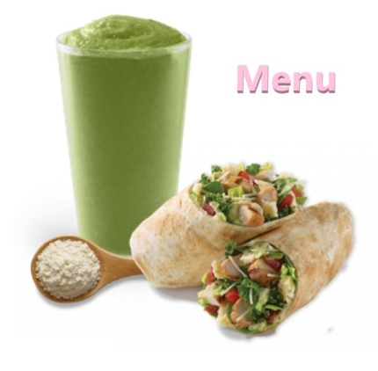

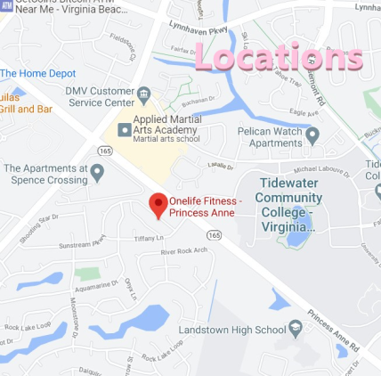

- About us page

Logo Picture of their food truck

Below are links to each page:

Home About us Menu Gallery Locations

**About us:**

**We are a local company that serves the Hampton Roads area and brings healthy food options to you. (More stuff)**

**Meet the owners:**

**(Picture and write-up of owner(s))**

- Menu Page

Logo Picture of their food truck

Below are links to each page:

Home About us Menu Gallery Locations

**Our Menu**

**Smoothies - $?.?? Fruit Cups - $?.??**

**Banana Smoothie** – 2 cups of frozen sliced banana, ½ cup nonfat plain Greek yogurt,1/2 tablespoon ground flax, 1 cup unsweetened plain almond milk, 1 teaspoon vanilla extract

**Strawberry-Banana Smoothie** - frozen or fresh strawberries and bananas, ½ cups of spinach, 1 cup of almond milk, 1 cup of ice, ½ cup nonfat plain Greek yogurt

**Apple Smoothie** - 2 4-oz apple sauce cups, frozen, 1 cup unsweetened almond milk or any milk, 2 tablespoon of rolled oats, 2 tablespoons of nut butter, 1 teaspoon of ground flax seed, 1 teaspoon maple syrup, ¼ teaspoon ground cinnamon

**Triple-Berry Smoothie** - 1.5 cups frozen triple berry mix, 1 medium frozen banana, ½ tablespoon chia seeds, ¼ cup vanilla protein powder, 1.25 cups unsweetened almond milk

**Mango Smoothie** - 2 cups frozen mango slices, 1 15-oz.can light coconut milk, ½ tablespoon flaxseed meal, 1 large frozen banana

**Peach Smoothie** - 1 medium banana, 1 ripe peach, 1 6 oz low fat peach yogurt, ¼ cup orange juice, 1 cup small ice cubes

**Watermelon Smoothie** - 1 ½ cups watermelon cubed, 1 cup strawberries trimmed, ½ cup milk, 1 tsp lemon juice, 2 Splenda sweetener packets

**Keto Smoothie** - 1 cup of cold water, 1 cup baby spinach, ½ cup cilantro, 1 inch ginger peeled, ¾ English cucumber peeled, ½-1 lemon peeled, 1 cup frozen avocado

**Fruit Cups** - Chopped up fruit of your choice packed in 100% fruit juice

- Photo Gallery Page

Logo Picture of their food truck

Home About us Menu Gallery Locations

**Photo Gallery**

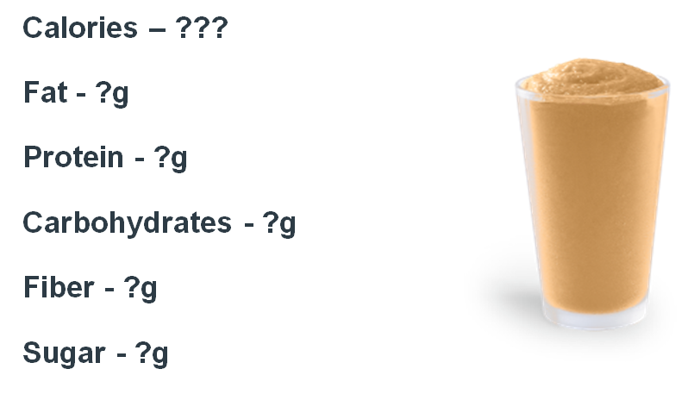

**Banana Smoothie**

- Locations Page

Logo Picture of their food truck

Home About us Menu Gallery Locations

**Truck Locations and Times:**

**(Day/time of truck locations with a Google map picture):**

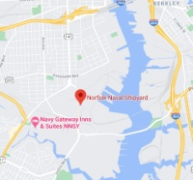**(For example:)**

**M-W-F 6:00-9:00 AM**

**Norfolk Naval Shipyard**

**(put link to map on above)**

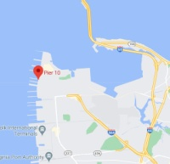

**M-W-F 11:00 AM -2:00 PM**

**Norfolk Naval Base Pier 10**

**(put link to map on above)**

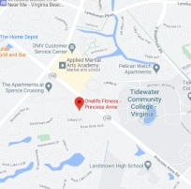

**M-W-F 4:00-7:00 PM**

**OneLife Gym Princess Anne**

**(put link to map on above)**